


Scope and Storyboard for Pre-Action Disclosure

Zurich Team, Manchester

By GQL

Table of Contents

1. Document Revision History 2
1.1. Document Location 2
1.2. Revision History 2
1.3. Reviewed by 2
1.4. Approvals (please complete ‘name’ column on first draft) 2
1.5. Distribution 2
2. Summary of Scope 4
3. Screen design 5
3.1. Disclosure (Form 1) 5
3.2. Disclosure – Produce List of Documents (Form 2) 16
4. Workflow 18
5. Navigation 19
5.1. Where will the Flow be launched from 19
5.2. Where should the Flow return to 19
6. SQL Tables 19
6.1. Table 19
6.2. Lookup 21
6.3. Field 21
7. Stored Procedures 21
7.1. Fetch 21
7.2. Save 21
8. Document Templates 25
9. Javascript 25

Document Revision History

Document Location
Full File Path

Revision History
Version Number | Revision Date | Summary of Changes | Changes marked | Author
1.0 | 26/07/2011 | First issue | n/a | GQL

Reviewed by
Name | Signature | Title | Date of Issue | Version
Lisa Williams |  | Project Manager
Andrea Brown |  | Senior Test Analyst
Mark Jenkinson |  | Project Liaison Officer

Approvals (please complete ‘name’ column on first draft)
Name | Signature or  Date of Approval Email | Title | Date of Issue | Version

Distribution
Name | Title | Date of Issue | Version

Summary of Scope

In certain circumstances, one party can require another to produce documents relevant to a potential claim, prior to the issue of proceedings. This may be necessary, for example, to assist a party to identify the proper defendant to the claim or to enable the potential claimant to plead its claim fully.

The following sections describe the amendments required to the FloCase system to provide for Pre-Action Disclosure from a Defendant point of view.

The process of Disclosure itself can be applied to both Pre-Litigated and Litigated matters so should therefore should be available for selection adhoc.

Screen design

Case Details

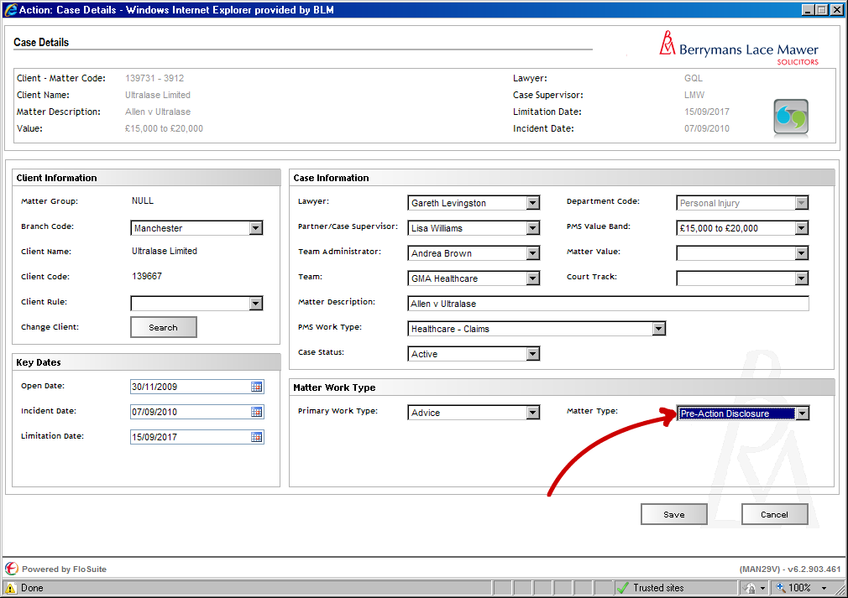
Figure 1 – Disclosure – Produce List of Documents

Form Availability
No change

Form Behaviour On Load
No change

Form Items
No change

Form Behaviour on Submit
If Primary Work Type = Advice and Matter Type = Pre-Action Disclosure, Schedule Disclosure (Form 1) for Lawyer on the matter.

Disclosure (Form 1)

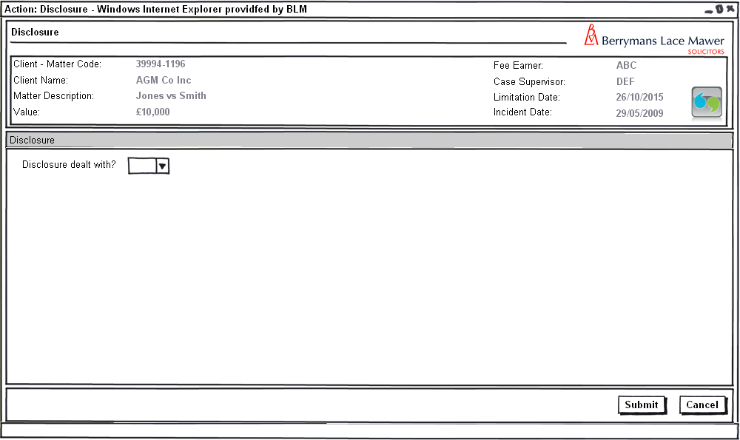
Figure 2 – Disclosure (On Load)

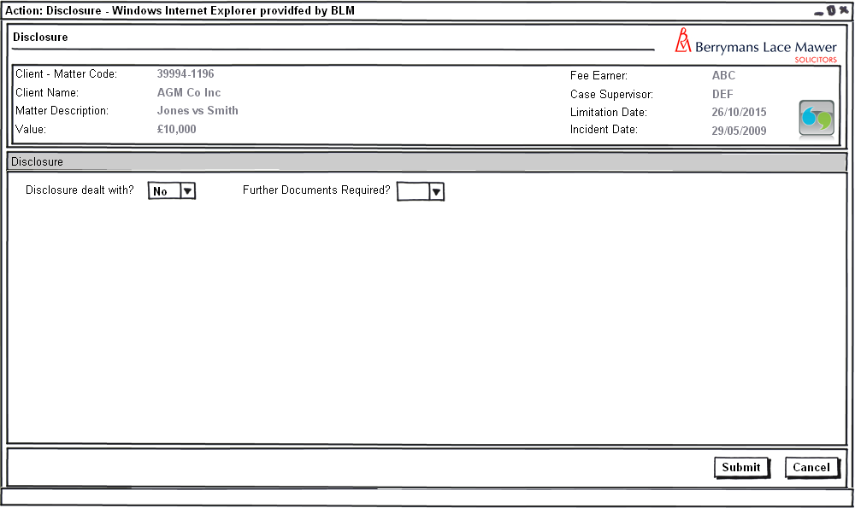
Figure 3 – Disclosure (Disclosure dealt with = No)
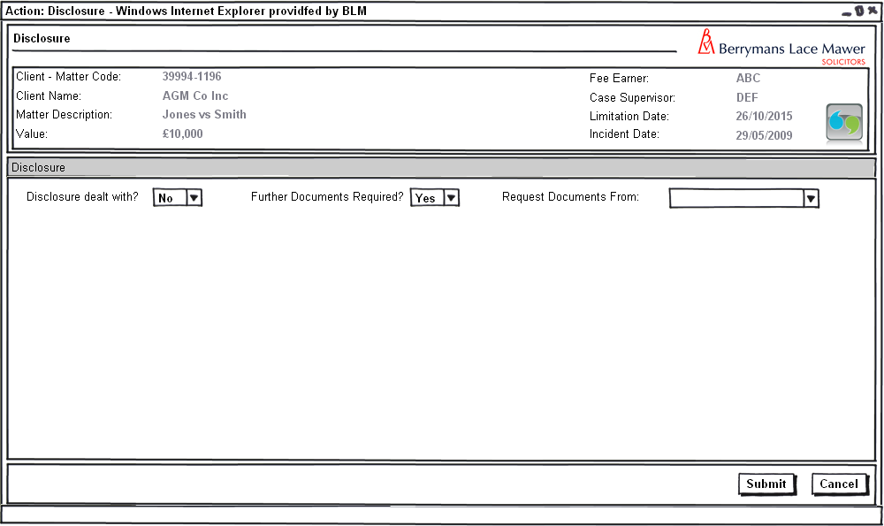
Figure 4 – Disclosure (Further Documents Required = Yes)

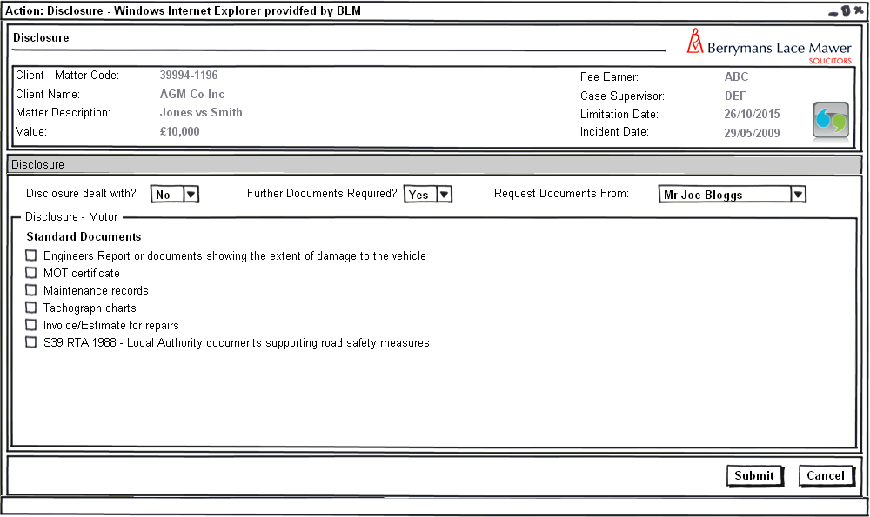
Figure 5 – Disclosure (Motor Documents)

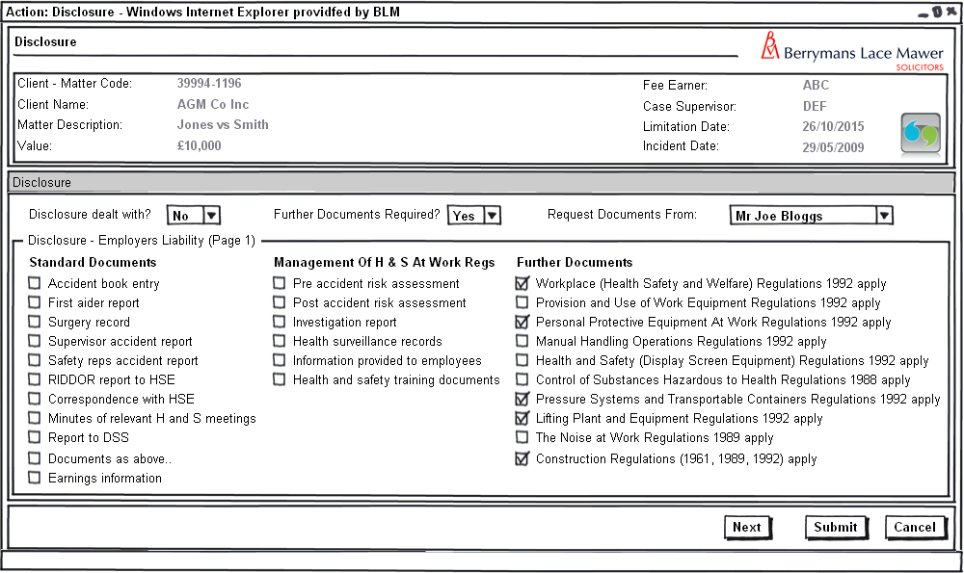
Figure 6 – Disclosure (EL Documents – Page 1)

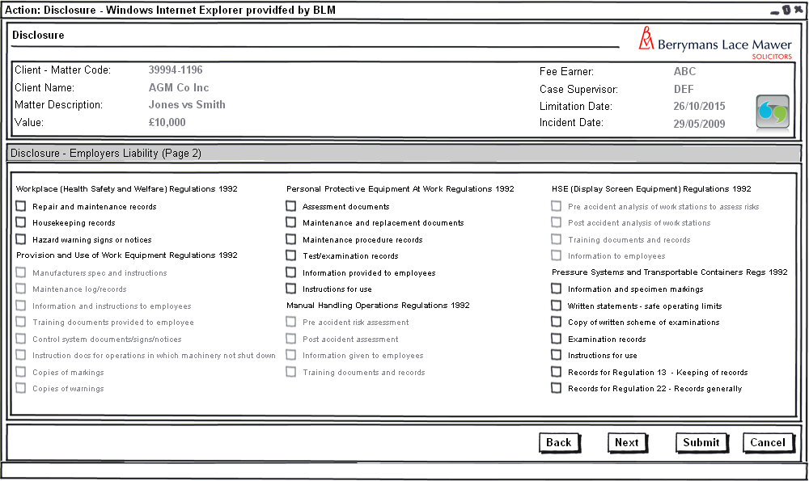
Figure 7 – Disclosure (EL Documents – Page 2)
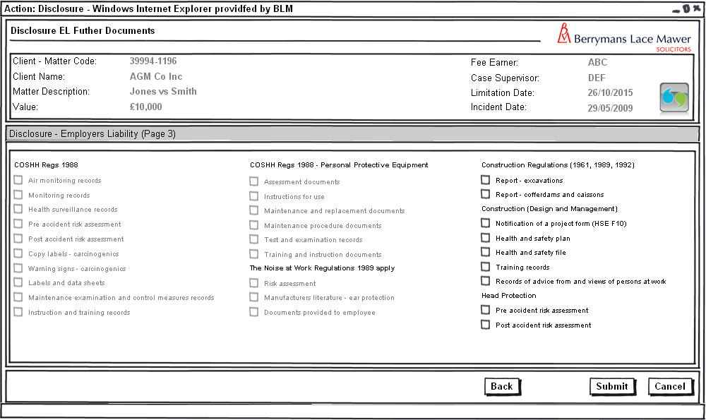
Figure 8 – Disclosure (EL Documents – Page 3)

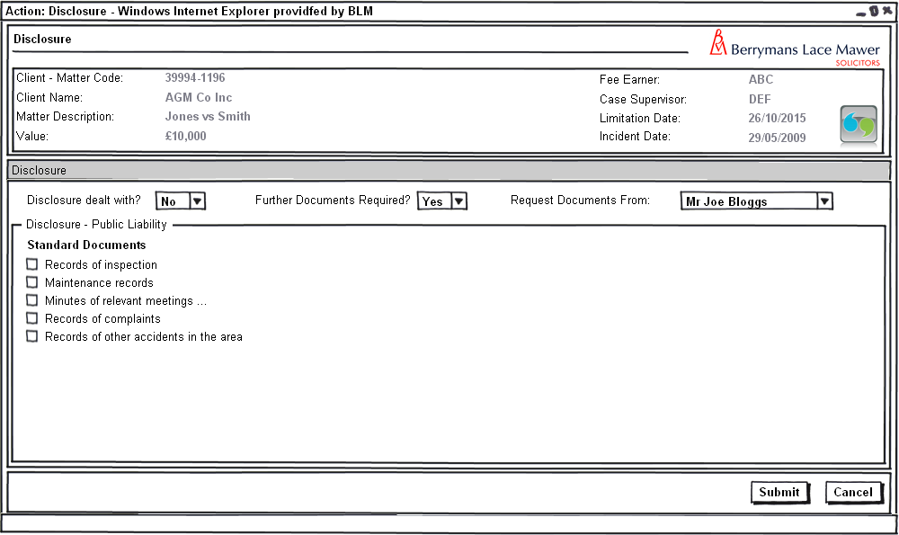
Figure 9 – Disclosure (PL Documents)

Form Availability
Form should be scheduled from Case Details as outlined in section 3.1 and also should be available for selection adhoc from the Case Actions Tab

Form Behaviour On Load
The form should load without any data pre-populated

New stored procedure, LTMM_MatterWorkType_Fetch, should be executed using the Matter CaseID and the System Username to return the Work Type of the Matter being accessed by the user.

Form Items

Disclosure dealt with? – Label as stated with associated Mandatory Combo box having the following options (Populated using LTMM_LookupCodes_Fetch with @LookupTypeCode = 'YesNo', @BlankRow = 1):
- Yes
- No

Further Documents Required? – Label as stated with associated Combo box having the following options (Populated using LTMM_LookupCodes_Fetch with @LookupTypeCode = 'YesNo', @BlankRow = 1):
- Yes
- No
This control should only be visible if Disclosure dealt with? = No, Mandatory field if Visible.

Request Documents From: – Label as stated with associated Combo box having the following options:
- All Active Contacts attached to the Matter populate via LTMM_CaseContacts_Fetch passing in the CaseID of the matter being Accessed
This control should only be visible if Further Documents Required? = ‘Yes’ and should be mandatory if visible.

Further Documents Required? On change if the value held in this field is yes the user should be presented with a series of checkboxes enabling them to select, from a predefined set of documents, those documents that they wish to request from the selected contact dealing with disclosure. These predefined sets are work type specific as follows (a new stored procedure, LTMM_MatterWorkType_Fetch, will be used to return the work type of a given Matter):
- Motor (LTMM_MatterWorkType_Fetch = ‘Motor’) – See Figure 5 with for items as follows:
    - Standard Documents – Label as stated
    - Engineers Report or documents showing the extent of damage to the vehicle – Label as stated with associated checkbox
    - MOT certificate – Label as stated with associated checkbox
    - Maintenance records – Label as stated with associated checkbox
    - Tachograph charts – Label as stated with associated checkbox
    - Invoice/Estimate for repairs – Label as stated with associated checkbox
    - S39 RTA 1988 - Local Authority documents supporting road safety measures – Label as stated with associated checkbox
- Employers Liability (LTMM_MatterWorkType_Fetch = ‘EL’) Page 1 – See Figure 6 with for items as follows:
    - Standard Documents – Label as stated
    - Accident book entry – Label as stated with associated checkbox
    - First aider report – Label as stated with associated checkbox
    - Surgery record – Label as stated with associated checkbox
    - Supervisor accident report – Label as stated with associated checkbox
    - Safety reps accident report – Label as stated with associated checkbox
    - RIDDOR report to HSE – Label as stated with associated checkbox
    - Correspondence with HSE – Label as stated with associated checkbox
    - Minutes of relevant H and S meetings – Label as stated with associated checkbox
    - Report to DSS – Label as stated with associated checkbox
    - Documents as above.. – Label as stated with associated checkbox
    - Earnings information – Label as stated with associated checkbox
    - Management Of H & S At Work Regs – Label as stated
    - Pre accident risk assessment – Label as stated with associated checkbox
    - Post accident risk assessment – Label as stated with associated checkbox
    - Investigation report – Label as stated with associated checkbox
    - Health surveillance records – Label as stated with associated checkbox
    - Information provided to employees – Label as stated with associated checkbox
    - Health and safety training documents – Label as stated with associated checkbox
    - Further Documents – Label as stated
    - Workplace (Health Safety and Welfare) Regulations 1992 apply – Label as stated with associated checkbox
    - Provision and Use of Work Equipment Regulations 1992 apply – Label as stated with associated checkbox
    - Personal Protective Equipment At Work Regulations 1992 apply – Label as stated with associated checkbox
    - Manual Handling Operations Regulations 1992 apply – Label as stated with associated checkbox
    - Health and Safety (Display Screen Equipment) Regulations 1992 apply – Label as stated with associated checkbox
    - Control of Substances Hazardous to Health Regulations 1988 apply – Label as stated with associated checkbox
    - Pressure Systems and Transportable Containers Regulations 1992 apply – Label as stated with associated checkbox
    - Lifting Plant and Equipment Regulations 1992 apply – Label as stated with associated checkbox
    - The Noise at Work Regulations 1989 apply – Label as stated with associated checkbox
    - Construction Regulations (1961, 1989, 1992) apply – Label as stated with associated checkbox
- Employers Liability (LTMM_MatterWorkType_Fetch = ‘EL’) Page 2 – See Figure 7 with for items as follows:
    - Workplace (Health Safety and Welfare) Regulations 1992 – Label as stated
    - Repair and maintenance records – Label as stated with associated checkbox, disabled if Workplace (Health Safety and Welfare) Regulations 1992 apply (on Employers Liability Page 1) = Unchecked.
    - Housekeeping records – Label as stated with associated checkbox, disabled if Workplace (Health Safety and Welfare) Regulations 1992 apply (on Employers Liability Page 1) = Unchecked.
    - Hazard warning signs or notices – Label as stated with associated checkbox, disabled if Workplace (Health Safety and Welfare) Regulations 1992 apply (on Employers Liability Page 1) = Unchecked.
    - Provision and Use of Work Equipment Regulations 1992 – Label as stated
    - Manufacturers spec and instructions – Label as stated with associated checkbox, disabled if Provision and Use of Work Equipment Regulations 1992 apply (on Employers Liability Page 1) = Unchecked.
    - Maintenance log/records – Label as stated with associated checkbox, disabled if Provision and Use of Work Equipment Regulations 1992 apply (on Employers Liability Page 1) = Unchecked.
    - Information and instructions to employees – Label as stated with associated checkbox, disabled if Provision and Use of Work Equipment Regulations 1992 apply (on Employers Liability Page 1) = Unchecked.
    - Training documents provided to employee – Label as stated with associated checkbox, disabled if Provision and Use of Work Equipment Regulations 1992 apply (on Employers Liability Page 1) = Unchecked.
    - Control system documents/signs/notices – Label as stated with associated checkbox, disabled if Provision and Use of Work Equipment Regulations 1992 apply (on Employers Liability Page 1) = Unchecked.
    - Instruction docs for operations in which machinery not shut down – Label as stated with associated checkbox, disabled if Provision and Use of Work Equipment Regulations 1992 apply (on Employers Liability Page 1) = Unchecked.
    - Copies of markings – Label as stated with associated checkbox, disabled if Provision and Use of Work Equipment Regulations 1992 apply (on Employers Liability Page 1) = Unchecked.
    - Copies of warnings – Label as stated with associated checkbox, disabled if Provision and Use of Work Equipment Regulations 1992 apply (on Employers Liability Page 1) = Unchecked.
    - Personal Protective Equipment At Work Regulations 1992 – Label as stated
    - Assessment documents – Label as stated with associated checkbox, disabled if Personal Protective Equipment At Work Regulations 1992 apply (on Employers Liability Page 1) = Unchecked.
    - Maintenance and replacement documents – Label as stated with associated checkbox, disabled if Personal Protective Equipment At Work Regulations 1992 apply (on Employers Liability Page 1) = Unchecked.
    - Maintenance procedure records – Label as stated with associated checkbox, disabled if Personal Protective Equipment At Work Regulations 1992 apply (on Employers Liability Page 1) = Unchecked.
    - Test/examination records – Label as stated with associated checkbox, disabled if Personal Protective Equipment At Work Regulations 1992 apply (on Employers Liability Page 1) = Unchecked.
    - Information provided to employees – Label as stated with associated checkbox, disabled if Personal Protective Equipment At Work Regulations 1992 apply (on Employers Liability Page 1) = Unchecked.
    - Instructions for use – Label as stated with associated checkbox, disabled if Personal Protective Equipment At Work Regulations 1992 apply (on Employers Liability Page 1) = Unchecked.
    - Manual Handling Operations Regulations 1992 – Label as stated
    - Pre accident risk assessment – Label as stated with associated checkbox, disabled if Manual Handling Operations Regulations 1992 apply (on Employers Liability Page 1) = Unchecked.
    - Post accident assessment – Label as stated with associated checkbox, disabled if Manual Handling Operations Regulations 1992 apply (on Employers Liability Page 1) = Unchecked.
    - Information given to employees – Label as stated with associated checkbox, disabled if Manual Handling Operations Regulations 1992 apply (on Employers Liability Page 1) = Unchecked.
    - Training documents and records – Label as stated with associated checkbox, disabled if Manual Handling Operations Regulations 1992 apply (on Employers Liability Page 1) = Unchecked.
    - HSE (Display Screen Equipment) Regulations 1992 – Label as stated
    - Pre accident analysis of work stations to assess risks – Label as stated with associated checkbox, disabled if HSE (Display Screen Equipment) Regulations 1992 apply (on Employers Liability Page 1) = Unchecked.
    - Post accident analysis of work stations – Label as stated with associated checkbox, disabled if HSE (Display Screen Equipment) Regulations 1992 apply (on Employers Liability Page 1) = Unchecked.
    - Training documents and records – Label as stated with associated checkbox, disabled if HSE (Display Screen Equipment) Regulations 1992 apply (on Employers Liability Page 1) = Unchecked.
    - Information to employees – Label as stated with associated checkbox, disabled if HSE (Display Screen Equipment) Regulations 1992 apply (on Employers Liability Page 1) = Unchecked.
    - Pressure Systems and Transportable Containers Regs 1992 – Label as stated
    - Information and specimen markings – Label as stated with associated checkbox, disabled if Pressure Systems and Transportable Containers Regs 1992 apply (on Employers Liability Page 1) = Unchecked.
    - Written statements - safe operating limits – Label as stated with associated checkbox, disabled if Pressure Systems and Transportable Containers Regs 1992 apply (on Employers Liability Page 1) = Unchecked.
    - Copy of written scheme of examinations – Label as stated with associated checkbox, disabled if Pressure Systems and Transportable Containers Regs 1992 apply (on Employers Liability Page 1) = Unchecked.
    - Examination records – Label as stated with associated checkbox, disabled if Pressure Systems and Transportable Containers Regs 1992 apply (on Employers Liability Page 1) = Unchecked.
    - Instructions for use – Label as stated with associated checkbox, disabled if Pressure Systems and Transportable Containers Regs 1992 apply (on Employers Liability Page 1) = Unchecked.
    - Records for Regulation 13 - Keeping of records – Label as stated with associated checkbox, disabled if Pressure Systems and Transportable Containers Regs 1992 apply (on Employers Liability Page 1) = Unchecked.
    - Records for Regulation 22 - Records generally – Label as stated with associated checkbox, disabled if Pressure Systems and Transportable Containers Regs 1992 apply (on Employers Liability Page 1) = Unchecked.
- Employers Liability (LTMM_MatterWorkType_Fetch = ‘EL’) Page 3 – See Figure 8 with for items as follows:
    - COSHH Regs 1988 – Label as stated
    - Air monitoring records – Label as stated with associated checkbox, disabled if Control of Substances Hazardous to Health Regulations 1988 apply (on Employers Liability Page 1) = Unchecked.
    - Monitoring records – Label as stated with associated checkbox, disabled if Control of Substances Hazardous to Health Regulations 1988 apply (on Employers Liability Page 1) = Unchecked.
    - Health surveillance records – Label as stated with associated checkbox, disabled if Control of Substances Hazardous to Health Regulations 1988 apply (on Employers Liability Page 1) = Unchecked.
    - Pre accident risk assessment – Label as stated with associated checkbox, disabled if Control of Substances Hazardous to Health Regulations 1988 apply (on Employers Liability Page 1) = Unchecked.
    - Post accident risk assessment – Label as stated with associated checkbox, disabled if Control of Substances Hazardous to Health Regulations 1988 apply (on Employers Liability Page 1) = Unchecked.
    - Copy labels – carcinogenics – Label as stated with associated checkbox, disabled if Control of Substances Hazardous to Health Regulations 1988 apply (on Employers Liability Page 1) = Unchecked.
    - Warning signs – carcinogenics – Label as stated with associated checkbox, disabled if Control of Substances Hazardous to Health Regulations 1988 apply (on Employers Liability Page 1) = Unchecked.
    - Labels and data sheets – Label as stated with associated checkbox, disabled if Control of Substances Hazardous to Health Regulations 1988 apply (on Employers Liability Page 1) = Unchecked.
    - Maintenance examination and control measures records – Label as stated with associated checkbox, disabled if Control of Substances Hazardous to Health Regulations 1988 apply (on Employers Liability Page 1) = Unchecked.
    - Instruction and training records – Label as stated with associated checkbox, disabled if Control of Substances Hazardous to Health Regulations 1988 apply (on Employers Liability Page 1) = Unchecked.
    - COSHH Regs 1988 - Personal Protective Equipment – Label as stated
    - Assessment documents – Label as stated with associated checkbox, disabled if Control of Substances Hazardous to Health Regulations 1988 apply (on Employers Liability Page 1) = Unchecked.
    - Instructions for use – Label as stated with associated checkbox, disabled if Control of Substances Hazardous to Health Regulations 1988 apply (on Employers Liability Page 1) = Unchecked.
    - Maintenance and replacement documents – Label as stated with associated checkbox, disabled if Control of Substances Hazardous to Health Regulations 1988 apply (on Employers Liability Page 1) = Unchecked.
    - Maintenance procedure documents – Label as stated with associated checkbox, disabled if Control of Substances Hazardous to Health Regulations 1988 apply (on Employers Liability Page 1) = Unchecked.
    - Test and examination records – Label as stated with associated checkbox, disabled if Control of Substances Hazardous to Health Regulations 1988 apply (on Employers Liability Page 1) = Unchecked.
    - Training and instruction documents – Label as stated with associated checkbox, disabled if Control of Substances Hazardous to Health Regulations 1988 apply (on Employers Liability Page 1) = Unchecked.
    - The Noise at Work Regulations 1989 apply – Label as stated
    - Risk assessment – Label as stated with associated checkbox, disabled if The Noise at Work Regulations 1989 apply (on Employers Liability Page 1) = Unchecked.
    - Manufacturers literature - ear protection – Label as stated with associated checkbox, disabled if The Noise at Work Regulations 1989 apply (on Employers Liability Page 1) = Unchecked.
    - Documents provided to employee – Label as stated with associated checkbox, disabled if The Noise at Work Regulations 1989 apply (on Employers Liability Page 1) = Unchecked.
    - Construction Regulations (1961, 1989, 1992) – Label as stated
    - Report – excavations – Label as stated with associated checkbox, disabled if Construction Regulations (1961, 1989, 1992) apply (on Employers Liability Page 1) = Unchecked.
    - Report - cofferdams and caissons – Label as stated with associated checkbox, disabled if Construction Regulations (1961, 1989, 1992) apply (on Employers Liability Page 1) = Unchecked.
    - Construction (Design and Management) – Label as stated
    - Notification of a project form (HSE F10) – Label as stated with associated checkbox, disabled if Construction Regulations (1961, 1989, 1992) apply (on Employers Liability Page 1) = Unchecked.
    - Health and safety plan – Label as stated with associated checkbox, disabled if Construction Regulations (1961, 1989, 1992) apply (on Employers Liability Page 1) = Unchecked.
    - Health and safety file – Label as stated with associated checkbox, disabled if Construction Regulations (1961, 1989, 1992) apply (on Employers Liability Page 1) = Unchecked.
    - Training records – Label as stated with associated checkbox, disabled if Construction Regulations (1961, 1989, 1992) apply (on Employers Liability Page 1) = Unchecked.
    - Records of advice from and views of persons at work – Label as stated with associated checkbox, disabled if Construction Regulations (1961, 1989, 1992) apply (on Employers Liability Page 1) = Unchecked.
    - Head Protection – Label as stated.
    - Pre accident risk assessment – Label as stated with associated checkbox, disabled if Construction Regulations (1961, 1989, 1992) apply (on Employers Liability Page 1) = Unchecked.
    - Post accident risk assessment – Label as stated with associated checkbox, disabled if Construction Regulations (1961, 1989, 1992) apply (on Employers Liability Page 1) = Unchecked.
- Public Liability (LTMM_MatterWorkType_Fetch = ‘PL’) – See Figure 9 with for items as follows:
    - Standard Documents – Label as stated
    - Records of inspection – Label as stated with associated checkbox
    - Maintenance records – Label as stated with associated checkbox
    - Minutes of relevant meetings ... – Label as stated with associated checkbox
    - Records of complaints – Label as stated with associated checkbox
    - Records of other accidents in the area – Label as stated with associated checkbox

NOTE: Matters that do not fall under these work types (LTMM_MatterWorkType_Fetch = ‘Other’) will not get any specific options for the user to select but will get a blank List of Documents (LOD) document to complete adhoc (see flow diagram in section 4)

Next – Button Labelled as stated. This control should only be visible if one of the following controls are checked on Employers Liability Page 1:
    - Workplace (Health Safety and Welfare) Regulations 1992 apply
    - Provision and Use of Work Equipment Regulations 1992 apply
    - Personal Protective Equipment At Work Regulations 1992 apply
    - Manual Handling Operations Regulations 1992 apply
    - Health and Safety (Display Screen Equipment) Regulations 1992 apply
    - Control of Substances Hazardous to Health Regulations 1988 apply
    - Pressure Systems and Transportable Containers Regulations 1992 apply
    - The Noise at Work Regulations 1989 apply
    - Construction Regulations (1961, 1989, 1992) apply.
The control should also only be visible on the following pages of the Disclosure form with actions as stated:
    - Employers Liability Page 1 – Display Employers Liability Page 2
    - Employers Liability Page 2 – Display Employers Liability Page 3
Back – Button Labelled as stated. This control should only be visible if one of the following controls are checked on Employers Liability Page 1:
    - Workplace (Health Safety and Welfare) Regulations 1992 apply
    - Provision and Use of Work Equipment Regulations 1992 apply
    - Personal Protective Equipment At Work Regulations 1992 apply
    - Manual Handling Operations Regulations 1992 apply
    - Health and Safety (Display Screen Equipment) Regulations 1992 apply
    - Control of Substances Hazardous to Health Regulations 1988 apply
    - Pressure Systems and Transportable Containers Regulations 1992 apply
    - The Noise at Work Regulations 1989 apply
    - Construction Regulations (1961, 1989, 1992) apply.
The control should also only be visible on the following pages of the Disclosure form with actions as stated:
    - Employers Liability Page 2 – Display Employers Liability Page 1
    - Employers Liability Page 3 – Display Employers Liability Page 2

Form Behaviour on Submit
Should return to the Matter Landing Page.
If Further Documents Required? = Yes, Write History line Disclosure Documents Requested from <<Disclosure Contact>>
If Further Documents Required? = Yes, produce a Letter Requesting LOD to Selected Disclosure Contact (see Figure 4 – Request Documents From), the letter should list all the documents that the user has check on this form.
If Further Documents Required? = No, produce LOD (Standard Disclosure) for the Lawyer to complete
If Further Documents Required? = Yes, Schedule Disclosure – Produce List of Documents (Form 2) for the Lawyer on the Matter for 7 days.

Use New Stored Procedure LTMM_Disclosure_Save to save the following details entered on the form:
- CASEID of the matter – Map to @pDisclosure_CaseID
- Disclosure dealt with? – Map to @pDisclosure_DiscDealtWith
- Further Documents Required? – Map to @pDisclosure_FurDocsReq
- Request Documents From: – Map to @pDisclosure_ReqDocsFrom
- Engineers Report or documents showing the extent of damage to the vehicle – Map to @pDisclosure_ExtDam
- MOT certificate – Map to @pDisclosure_MOT
- Maintenance records – Map to @pDisclosure_MaintRep
- Tachograph charts – Map to @pDisclosure_Tacho
- Invoice/Estimate for repairs – Map to @pDisclosure_ComMaintRep
- S39 RTA 1988 - Local Authority documents supporting road safety measures – Map to @pDisclosure_LocalAuth
- Accident book entry – Map to @pDisclosure_AccidBook
- First aider report – Map to @pDisclosure_FirstAid
- Surgery record – Map to @pDisclosure_SurgeryRec
- Supervisor accident report – Map to @pDisclosure_SuperAccidRep
- Safety reps accident report – Map to @pDisclosure_SafeRepAccidRep
- RIDDOR report to HSE – Map to @pDisclosure_Riddorrep
- Correspondence with HSE – Map to @pDisclosure_OtherComms
- Minutes of relevant H and S meetings – Map to @pDisclosure_MinsHlthSafe
- Report to DSS – Map to @pDisclosure_DSSRep
- Documents as above.. – Map to @pDisclosure_SimilAccidDocs
- Earnings information – Map to @pDisclosure_EarningInfo
- Pre accident risk assessment – Map to @pDisclosure_PreAccidRisk
- Post accident risk assessment – Map to @pDisclosure_PostAccidRisk
- Investigation report – Map to @pDisclosure_AccidInvestRecs
- Health surveillance records – Map to @pDisclosure_HealthSurvRep
- Information provided to employees – Map to @pDisclosure_InfoToEmps
- Health and safety training documents – Map to @pDisclosure_HandSTrainDocs
- Workplace (Health Safety and Welfare) Regulations 1992 apply – Map to @pDisclosure_WorkPlaceReg
- Provision and Use of Work Equipment Regulations 1992 apply – Map to @pDisclosure_WorkEquipReg
- Personal Protective Equipment At Work Regulations 1992 apply – Map to @pDisclosure_ProtectEquipReg
- Manual Handling Operations Regulations 1992 apply – Map to @pDisclosure_ManHandReg
- Health and Safety (Display Screen Equipment) Regulations 1992 apply – Map to @pDisclosure_DispScreenReg
- Control of Substances Hazardous to Health Regulations 1988 apply – Map to @pDisclosure_COSHHReg
- Pressure Systems and Transportable Containers Regulations 1992 apply – Map to @pDisclosure_PressGasReg
- Lifting Plant and Equipment Regulations 1992 apply – Map to @pDisclosure_LiftingReg
- The Noise at Work Regulations 1989 apply – Map to @pDisclosure_NoiseReg
- Construction Regulations (1961, 1989, 1992) apply – Map to @pDisclosure_ConstructGenReg
- Repair and maintenance records – Map to @pDisclosure_WPRepMaintRecs
- Housekeeping records – Map to @pDisclosure_WPHouseKeepRecs
- Hazard warning signs or notices – Map to @pDisclosure_WPHazardSign
- Manufacturers spec and instructions – Map to @pDisclosure_WEManSpec
- Maintenance log/records – Map to @pDisclosure_WEMaintLog
- Information and instructions to employees – Map to @pDisclosure_WEInfoToEmps
- Training documents provided to employee – Map to @pDisclosure_WETrainDocs
- Control system documents/signs/notices – Map to @pDisclosure_WENoticeSign
- Instruction docs for operations in which machinery not shut down – Map to @pDisclosure_WEInstructDocs
- Copies of markings – Map to @pDisclosure_WECopyMark
- Copies of warnings – Map to @pDisclosure_WECopyWarn
- Assessment documents – Map to @pDisclosure_PEAssessDocs
- Maintenance and replacement documents – Map to @pDisclosure_PEMaintRepDocs
- Maintenance procedure records – Map to @pDisclosure_PEMaintProcDocs
- Test/examination records – Map to @pDisclosure_PETestDocs
- Information provided to employees – Map to @pDisclosure_PEInfoToEmps
- Instructions for use – Map to @pDisclosure_PEInstructDocs
- Pre accident risk assessment – Map to @pDisclosure_MHPreAccidRisk
- Post accident assessment – Map to @pDisclosure_MHPostAccidRisk
- Information given to employees – Map to @pDisclosure_MHInfoToEmps
- Training documents and records – Map to @pDisclosure_MHTrainDocs
- Pre accident analysis of work stations to assess risks – Map to @pDisclosure_DSPreAccidRisk
- Post accident analysis of work stations – Map to @pDisclosure_DSPostAccidRisk
- Training documents and records – Map to @pDisclosure_DSTrainDocs
- Information to employees – Map to @pDisclosure_DSInfoToEmps
- Information and specimen markings – Map to @pDisclosure_PGSpecMarking
- Written statements - safe operating limits – Map to @pDisclosure_PGWrittenStatmnt
- Copy of written scheme of examinations – Map to @pDisclosure_PGCopyWrittenStatmnt
- Examination records – Map to @pDisclosure_PGExamRecs
- Instructions for use – Map to @pDisclosure_PGInstructUse
- Records for Regulation 13 - Keeping of records – Map to @pDisclosure_PGRecsA
- Records for Regulation 22 - Records generally – Map to @pDisclosure_PGRecsB
- Air monitoring records – Map to @pDisclosure_CHAirMonitorRecs
- Monitoring records – Map to @pDisclosure_CHMonitorRecs
- Health surveillance records – Map to @pDisclosure_CHHlthSurvRecs
- Pre accident risk assessment – Map to @pDisclosure_CHPreAccidRisk
- Post accident risk assessment – Map to @pDisclosure_CHPostAccidRisk
- Copy labels – carcinogenics – Map to @pDisclosure_CHCopyLabel
- Warning signs – carcinogenics – Map to @pDisclosure_CHWarnSign
- Labels and data sheets – Map to @pDisclosure_CHLabelData
- Maintenance examination and control measures records – Map to @pDisclosure_CHMaintExamRecs
- Instruction and training records – Map to @pDisclosure_CHTrainDocs
- Assessment documents – Map to @pDisclosure_CHAssessDocs
- Instructions for use – Map to @pDisclosure_CHInstructUse
- Maintenance and replacement documents – Map to @pDisclosure_CHMaintRepDocs
- Maintenance procedure documents – Map to @pDisclosure_CHMaintProcDocs
- Test and examination records – Map to @pDisclosure_CHTestRecs
- Training and instruction documents – Map to @pDisclosure_CHInfoToEmps
- Risk assessment – Map to @pDisclosure_NRiskAssess
- Manufacturers literature - ear protection – Map to @pDisclosure_NManufactLit
- Documents provided to employee – Map to @pDisclosure_NInfoToEmps
- Report – excavations – Map to @pDisclosure_CGRepExcavn
- Report - cofferdams and caissons – Map to @pDisclosure_CGRepCoffer
- Notification of a project form (HSE F10) – Map to @pDisclosure_DMProjectForm
- Health and safety plan – Map to @pDisclosure_DMPlan
- Health and safety file – Map to @pDisclosure_DMFile
- Training records – Map to @pDisclosure_DMTrainDocs
- Records of advice from and views of persons at work – Map to @pDisclosure_DMAdviceRecs
- Pre accident risk assessment – Map to @pDisclosure_HPPreAccidRisk
- Post accident risk assessment – Map to @pDisclosure_HPPostAccidRisk
- Records of inspection – Map to @pDisclosure_InspectionRecs
- Maintenance records – Map to @pDisclosure_MaintRecs
- Minutes of relevant meetings ... – Map to @pDisclosure_PolicyMins
- Records of complaints – Map to @pDisclosure_ComplaintRecs
- Records of other accidents in the area – Map to @pDisclosure_OtherAccidRecs
- 0 – Map to @pDisclosure_InActive
- System Username – Map to @pDisclosure_CreateUser

Form Behaviour on Cancel
Return to the Matter Landing Page.

Disclosure – Produce List of Documents (Form 2)

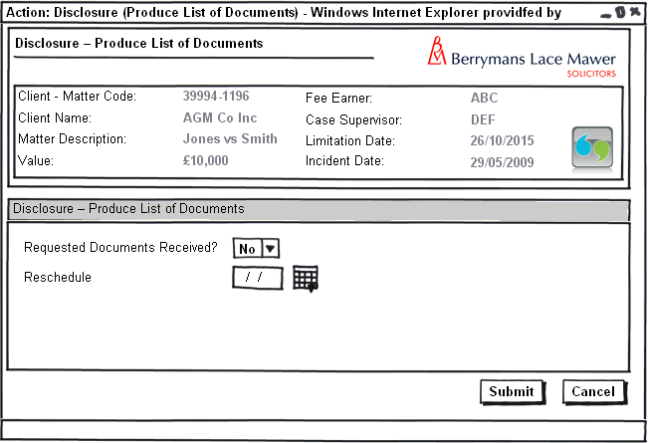
Figure 10– Disclosure – Produce List of Documents

Form Availability
Form should only be available when scheduled as part of a flow

Form Behaviour On Load
The form should load without any data pre-populated

Form Items

Requested Documents Received? – Label as stated with associated Mandatory Combo box having the following options (Populated using LTMM_LookupCodes_Fetch with @LookupTypeCode = 'YesNo', @BlankRow = 1):
- Yes
- No

Reschedule – Label as stated with associated Date Picker. This control should only be visible if Requested Documents Received? = No, Mandatory field if Visible.

Form Behaviour on Submit
Should return to the Matter Landing Page.
If Requested Documents Received? = Yes Write History line Disclosure Documents Received from <<Disclosure Contact>>
If Requested Documents Received? = Yes Produce LOD (Standard Disclosure) for the Lawyer to complete
If Requested Documents Received? = No Schedule Disclosure – Produce List of Documents (Form 2) for the Lawyer on the Matter for the date entered in Reschedule.

Form Behaviour on Cancel
Return to the Matter Landing Page.

Workflow

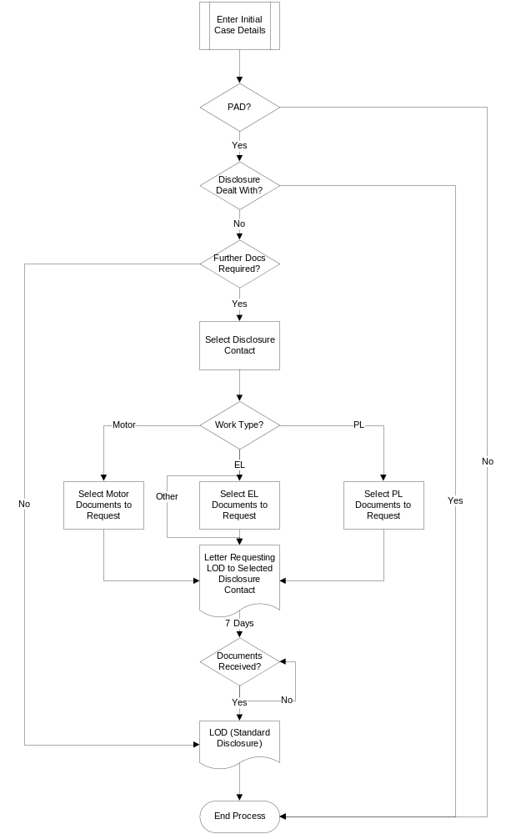
Figure 11 – Pre-Action Disclosure Flow

Navigation

Where will the Flow be launched from

Disclosure (Form 1) should either be launched from Update Case Details if the case is marked as Pre-Action Disclosure or selected adhoc from the Case Actions Tab.

Disclosure – Produce List of Documents (Form 2) should only be scheduled from Disclosure (Form 1) if further documents are required.

Where should the Flow return to

Disclosure (Form 1) upon submission should return to the Matter Landing Page.

Disclosure – Produce List of Documents (Form 2) upon submission should return to the Matter Landing Page.

SQL Tables

Table

New Table Disclosure with the following columns:
    - Disclosure_DisclosureID - Type int
    - Disclosure_DisclosureCode - Type Varchar(255)
    - Disclosure_CaseID - Type int
    - Disclosure_DiscDealtWith - Type Varchar(255)
    - Disclosure_FurDocsReq - Type Varchar(255)
    - Disclosure_ReqDocsFrom - Type int
    - Disclosure_ExtDam - Type Bit (Default 0)
    - Disclosure_MOT - Type Bit (Default 0)
    - Disclosure_MaintRep - Type Bit (Default 0)
    - Disclosure_Tacho - Type Bit (Default 0)
    - Disclosure_ComMaintRep - Type Bit (Default 0)
    - Disclosure_LocalAuth - Type Bit (Default 0)
    - Disclosure_AccidBook - Type Bit (Default 0)
    - Disclosure_FirstAid - Type Bit (Default 0)
    - Disclosure_SurgeryRec - Type Bit (Default 0)
    - Disclosure_SuperAccidRep - Type Bit (Default 0)
    - Disclosure_SafeRepAccidRep - Type Bit (Default 0)
    - Disclosure_Riddorrep - Type Bit (Default 0)
    - Disclosure_OtherComms - Type Bit (Default 0)
    - Disclosure_MinsHlthSafe - Type Bit (Default 0)
    - Disclosure_DSSRep - Type Bit (Default 0)
    - Disclosure_SimilAccidDocs - Type Bit (Default 0)
    - Disclosure_EarningInfo - Type Bit (Default 0)
    - Disclosure_PreAccidRisk - Type Bit (Default 0)
    - Disclosure_PostAccidRisk - Type Bit (Default 0)
    - Disclosure_AccidInvestRecs - Type Bit (Default 0)
    - Disclosure_HealthSurvRep - Type Bit (Default 0)
    - Disclosure_InfoToEmps - Type Bit (Default 0)
    - Disclosure_HandSTrainDocs - Type Bit (Default 0)
    - Disclosure_WorkPlaceReg - Type Bit (Default 0)
    - Disclosure_WorkEquipReg - Type Bit (Default 0)
    - Disclosure_ProtectEquipReg - Type Bit (Default 0)
    - Disclosure_ManHandReg - Type Bit (Default 0)
    - Disclosure_DispScreenReg - Type Bit (Default 0)
    - Disclosure_COSHHReg - Type Bit (Default 0)
    - Disclosure_PressGasReg - Type Bit (Default 0)
    - Disclosure_LiftingReg - Type Bit (Default 0)
    - Disclosure_NoiseReg - Type Bit (Default 0)
    - Disclosure_ConstructGenReg - Type Bit (Default 0)
    - Disclosure_WPRepMaintRecs - Type Bit (Default 0)
    - Disclosure_WPHouseKeepRecs - Type Bit (Default 0)
    - Disclosure_WPHazardSign - Type Bit (Default 0)
    - Disclosure_WEManSpec - Type Bit (Default 0)
    - Disclosure_WEMaintLog - Type Bit (Default 0)
    - Disclosure_WEInfoToEmps - Type Bit (Default 0)
    - Disclosure_WETrainDocs - Type Bit (Default 0)
    - Disclosure_WENoticeSign - Type Bit (Default 0)
    - Disclosure_WEInstructDocs - Type Bit (Default 0)
    - Disclosure_WECopyMark - Type Bit (Default 0)
    - Disclosure_WECopyWarn - Type Bit (Default 0)
    - Disclosure_PEAssessDocs - Type Bit (Default 0)
    - Disclosure_PEMaintRepDocs - Type Bit (Default 0)
    - Disclosure_PEMaintProcDocs - Type Bit (Default 0)
    - Disclosure_PETestDocs - Type Bit (Default 0)
    - Disclosure_PEInfoToEmps - Type Bit (Default 0)
    - Disclosure_PEInstructDocs - Type Bit (Default 0)
    - Disclosure_MHPreAccidRisk - Type Bit (Default 0)
    - Disclosure_MHPostAccidRisk - Type Bit (Default 0)
    - Disclosure_MHInfoToEmps - Type Bit (Default 0)
    - Disclosure_MHTrainDocs - Type Bit (Default 0)
    - Disclosure_DSPreAccidRisk - Type Bit (Default 0)
    - Disclosure_DSPostAccidRisk - Type Bit (Default 0)
    - Disclosure_DSTrainDocs - Type Bit (Default 0)
    - Disclosure_DSInfoToEmps - Type Bit (Default 0)
    - Disclosure_PGSpecMarking - Type Bit (Default 0)
    - Disclosure_PGWrittenStatmnt - Type Bit (Default 0)
    - Disclosure_PGCopyWrittenStatmnt - Type Bit (Default 0)
    - Disclosure_PGExamRecs - Type Bit (Default 0)
    - Disclosure_PGInstructUse - Type Bit (Default 0)
    - Disclosure_PGRecsA - Type Bit (Default 0)
    - Disclosure_PGRecsB - Type Bit (Default 0)
    - Disclosure_CHAirMonitorRecs - Type Bit (Default 0)
    - Disclosure_CHMonitorRecs - Type Bit (Default 0)
    - Disclosure_CHHlthSurvRecs - Type Bit (Default 0)
    - Disclosure_CHPreAccidRisk - Type Bit (Default 0)
    - Disclosure_CHPostAccidRisk - Type Bit (Default 0)
    - Disclosure_CHCopyLabel - Type Bit (Default 0)
    - Disclosure_CHWarnSign - Type Bit (Default 0)
    - Disclosure_CHLabelData - Type Bit (Default 0)
    - Disclosure_CHMaintExamRecs - Type Bit (Default 0)
    - Disclosure_CHTrainDocs - Type Bit (Default 0)
    - Disclosure_CHAssessDocs - Type Bit (Default 0)
    - Disclosure_CHInstructUse - Type Bit (Default 0)
    - Disclosure_CHMaintRepDocs - Type Bit (Default 0)
    - Disclosure_CHMaintProcDocs - Type Bit (Default 0)
    - Disclosure_CHTestRecs - Type Bit (Default 0)
    - Disclosure_CHInfoToEmps - Type Bit (Default 0)
    - Disclosure_NRiskAssess - Type Bit (Default 0)
    - Disclosure_NManufactLit - Type Bit (Default 0)
    - Disclosure_NInfoToEmps - Type Bit (Default 0)
    - Disclosure_CGRepExcavn - Type Bit (Default 0)
    - Disclosure_CGRepCoffer - Type Bit (Default 0)
    - Disclosure_DMProjectForm - Type Bit (Default 0)
    - Disclosure_DMPlan - Type Bit (Default 0)
    - Disclosure_DMFile - Type Bit (Default 0)
    - Disclosure_DMTrainDocs - Type Bit (Default 0)
    - Disclosure_DMAdviceRecs - Type Bit (Default 0)
    - Disclosure_HPPreAccidRisk - Type Bit (Default 0)
    - Disclosure_HPPostAccidRisk - Type Bit (Default 0)
    - Disclosure_InspectionRecs - Type Bit (Default 0)
    - Disclosure_MaintRecs - Type Bit (Default 0)
    - Disclosure_PolicyMins - Type Bit (Default 0)
    - Disclosure_ComplaintRecs - Type Bit (Default 0)
    - Disclosure_OtherAccidRecs - Type Bit (Default 0)
    - Disclosure_InActive - Type Bit (Default 0)
    - Disclosure_CreateUser - Type Varchar(255)
    - Disclosure_CreateDate - Type smalldatetime (Default GetDate())

Lookup

n/a

Field

n/a

Stored Procedures

Fetch

LTMM_MatterWorkType_Fetch

Inputs:
@pMatterWorkType_CaseID - Type int
@pUserName - Type Varchar(255)

Outputs:

From Case Table

IF Case_PriCaseType = ‘PRIINJ’ and Case_SecCaseTypeInj = ‘SINJMOTOR’
Return ‘Motor’ as Work Type

IF Case_PriCaseType = ‘PRIINJ’ and Case_SecCaseTypeInj = ‘SINJEL’
Return ‘EL’ as Work Type

IF Case_PriCaseType = ‘PRIINJ’ and Case_SecCaseTypeInj = ‘SINJPL’
Return ‘PL’ as Work Type

Else
Return ‘Other’ as Work Type

LTMM_Directions_Fetch

Inputs:
@pDisclosure_DisclosureCode - Type Varchar(255)
@pDisclosure_CaseID - Type int
@pUserName - Type Varchar(255)

Outputs:

The following fields from the new Disclosure filtered by the inputs @pDisclosure_DisclosureCode and @pDisclosure_CaseID if supplied:
    - Disclosure_DisclosureID
    - Disclosure_DisclosureCode
    - Disclosure_CaseID
    - Disclosure_DiscDealtWith
    - Disclosure_FurDocsReq
    - Disclosure_ReqDocsFrom
    - Disclosure_ExtDam
    - Disclosure_MOT
    - Disclosure_MaintRep
    - Disclosure_Tacho
    - Disclosure_ComMaintRep
    - Disclosure_LocalAuth
    - Disclosure_AccidBook
    - Disclosure_FirstAid
    - Disclosure_SurgeryRec
    - Disclosure_SuperAccidRep
    - Disclosure_SafeRepAccidRep
    - Disclosure_Riddorrep
    - Disclosure_OtherComms
    - Disclosure_MinsHlthSafe
    - Disclosure_DSSRep
    - Disclosure_SimilAccidDocs
    - Disclosure_EarningInfo
    - Disclosure_PreAccidRisk
    - Disclosure_PostAccidRisk
    - Disclosure_AccidInvestRecs
    - Disclosure_HealthSurvRep
    - Disclosure_InfoToEmps
    - Disclosure_HandSTrainDocs
    - Disclosure_WorkPlaceReg
    - Disclosure_WorkEquipReg
    - Disclosure_ProtectEquipReg
    - Disclosure_ManHandReg
    - Disclosure_DispScreenReg
    - Disclosure_COSHHReg
    - Disclosure_PressGasReg
    - Disclosure_LiftingReg
    - Disclosure_NoiseReg
    - Disclosure_ConstructGenReg
    - Disclosure_WPRepMaintRecs
    - Disclosure_WPHouseKeepRecs
    - Disclosure_WPHazardSign
    - Disclosure_WEManSpec
    - Disclosure_WEMaintLog
    - Disclosure_WEInfoToEmps
    - Disclosure_WETrainDocs
    - Disclosure_WENoticeSign
    - Disclosure_WEInstructDocs
    - Disclosure_WECopyMark
    - Disclosure_WECopyWarn
    - Disclosure_PEAssessDocs
    - Disclosure_PEMaintRepDocs
    - Disclosure_PEMaintProcDocs
    - Disclosure_PETestDocs
    - Disclosure_PEInfoToEmps
    - Disclosure_PEInstructDocs
    - Disclosure_MHPreAccidRisk
    - Disclosure_MHPostAccidRisk
    - Disclosure_MHInfoToEmps
    - Disclosure_MHTrainDocs
    - Disclosure_DSPreAccidRisk
    - Disclosure_DSPostAccidRisk
    - Disclosure_DSTrainDocs
    - Disclosure_DSInfoToEmps
    - Disclosure_PGSpecMarking
    - Disclosure_PGWrittenStatmnt
    - Disclosure_PGCopyWrittenStatmnt
    - Disclosure_PGExamRecs
    - Disclosure_PGInstructUse
    - Disclosure_PGRecsA
    - Disclosure_PGRecsB
    - Disclosure_CHAirMonitorRecs
    - Disclosure_CHMonitorRecs
    - Disclosure_CHHlthSurvRecs
    - Disclosure_CHPreAccidRisk
    - Disclosure_CHPostAccidRisk
    - Disclosure_CHCopyLabel
    - Disclosure_CHWarnSign
    - Disclosure_CHLabelData
    - Disclosure_CHMaintExamRecs
    - Disclosure_CHTrainDocs
    - Disclosure_CHAssessDocs
    - Disclosure_CHInstructUse
    - Disclosure_CHMaintRepDocs
    - Disclosure_CHMaintProcDocs
    - Disclosure_CHTestRecs
    - Disclosure_CHInfoToEmps
    - Disclosure_NRiskAssess
    - Disclosure_NManufactLit
    - Disclosure_NInfoToEmps
    - Disclosure_CGRepExcavn
    - Disclosure_CGRepCoffer
    - Disclosure_DMProjectForm
    - Disclosure_DMPlan
    - Disclosure_DMFile
    - Disclosure_DMTrainDocs
    - Disclosure_DMAdviceRecs
    - Disclosure_HPPreAccidRisk
    - Disclosure_HPPostAccidRisk
    - Disclosure_InspectionRecs
    - Disclosure_MaintRecs
    - Disclosure_PolicyMins
    - Disclosure_ComplaintRecs
    - Disclosure_OtherAccidRecs
    - Disclosure_InActive
    - Disclosure_CreateUser
    - Disclosure_CreateDate

Note: there is no apparent use for this stored procedure within the bounds of this scope document, its addition is merely for completeness.

Save

LTMM_Directions_Save

Inputs:
@pDisclosure_DisclosureCode - Type Varchar(255) (INPUT A)
@pDisclosure_CaseID - Type int (INPUT B)
@pDisclosure_DiscDealtWith - Type Varchar(255) (INPUT C)
@pDisclosure_FurDocsReq - Type Varchar(255) (INPUT D)
@pDisclosure_ReqDocsFrom - Type int (INPUT E)
@pDisclosure_ExtDam - Type Bit (INPUT F)
@pDisclosure_MOT - Type Bit (INPUT G)
@pDisclosure_MaintRep - Type Bit (INPUT H)
@pDisclosure_Tacho - Type Bit (INPUT I)
@pDisclosure_ComMaintRep - Type Bit (INPUT J)
@pDisclosure_LocalAuth - Type Bit (INPUT K)
@pDisclosure_AccidBook - Type Bit (INPUT L)
@pDisclosure_FirstAid - Type Bit (INPUT M)
@pDisclosure_SurgeryRec - Type Bit (INPUT N)
@pDisclosure_SuperAccidRep - Type Bit (INPUT O)
@pDisclosure_SafeRepAccidRep - Type Bit (INPUT P)
@pDisclosure_Riddorrep - Type Bit (INPUT Q)
@pDisclosure_OtherComms - Type Bit (INPUT R)
@pDisclosure_MinsHlthSafe - Type Bit (INPUT S)
@pDisclosure_DSSRep - Type Bit (INPUT T)
@pDisclosure_SimilAccidDocs - Type Bit (INPUT U)
@pDisclosure_EarningInfo - Type Bit (INPUT V)
@pDisclosure_PreAccidRisk - Type Bit (INPUT W)
@pDisclosure_PostAccidRisk - Type Bit (INPUT X)
@pDisclosure_AccidInvestRecs - Type Bit (INPUT Y)
@pDisclosure_HealthSurvRep - Type Bit (INPUT Z)
@pDisclosure_InfoToEmps - Type Bit (INPUT BA)
@pDisclosure_HandSTrainDocs - Type Bit (INPUT BB)
@pDisclosure_WorkPlaceReg - Type Bit (INPUT BC)
@pDisclosure_WorkEquipReg - Type Bit (INPUT BD)
@pDisclosure_ProtectEquipReg - Type Bit (INPUT BE)
@pDisclosure_ManHandReg - Type Bit (INPUT BF)
@pDisclosure_DispScreenReg - Type Bit (INPUT BG)
@pDisclosure_COSHHReg - Type Bit (INPUT BH)
@pDisclosure_PressGasReg - Type Bit (INPUT BI)
@pDisclosure_LiftingReg - Type Bit (INPUT BJ)
@pDisclosure_NoiseReg - Type Bit (INPUT BK)
@pDisclosure_ConstructGenReg - Type Bit (INPUT BL)
@pDisclosure_WPRepMaintRecs - Type Bit (INPUT BM)
@pDisclosure_WPHouseKeepRecs - Type Bit (INPUT BN)
@pDisclosure_WPHazardSign - Type Bit (INPUT BO)
@pDisclosure_WEManSpec - Type Bit (INPUT BP)
@pDisclosure_WEMaintLog - Type Bit (INPUT BQ)
@pDisclosure_WEInfoToEmps - Type Bit (INPUT BR)
@pDisclosure_WETrainDocs - Type Bit (INPUT BS)
@pDisclosure_WENoticeSign - Type Bit (INPUT BT)
@pDisclosure_WEInstructDocs - Type Bit (INPUT BU)
@pDisclosure_WECopyMark - Type Bit (INPUT BV)
@pDisclosure_WECopyWarn - Type Bit (INPUT BW)
@pDisclosure_PEAssessDocs - Type Bit (INPUT BX)
@pDisclosure_PEMaintRepDocs - Type Bit (INPUT BY)
@pDisclosure_PEMaintProcDocs - Type Bit (INPUT BZ)
@pDisclosure_PETestDocs - Type Bit (INPUT CA)
@pDisclosure_PEInfoToEmps - Type Bit (INPUT CB)
@pDisclosure_PEInstructDocs - Type Bit (INPUT CC)
@pDisclosure_MHPreAccidRisk - Type Bit (INPUT CD)
@pDisclosure_MHPostAccidRisk - Type Bit (INPUT CE)
@pDisclosure_MHInfoToEmps - Type Bit (INPUT CF)
@pDisclosure_MHTrainDocs - Type Bit (INPUT CG)
@pDisclosure_DSPreAccidRisk - Type Bit (INPUT CH)
@pDisclosure_DSPostAccidRisk - Type Bit (INPUT CI)
@pDisclosure_DSTrainDocs - Type Bit (INPUT CJ)
@pDisclosure_DSInfoToEmps - Type Bit (INPUT CK)
@pDisclosure_PGSpecMarking - Type Bit (INPUT CL)
@pDisclosure_PGWrittenStatmnt - Type Bit (INPUT CM)
@pDisclosure_PGCopyWrittenStatmnt - Type Bit (INPUT CN)
@pDisclosure_PGExamRecs - Type Bit (INPUT CO)
@pDisclosure_PGInstructUse - Type Bit (INPUT CP)
@pDisclosure_PGRecsA - Type Bit (INPUT CQ)
@pDisclosure_PGRecsB - Type Bit (INPUT CR)
@pDisclosure_CHAirMonitorRecs - Type Bit (INPUT CS)
@pDisclosure_CHMonitorRecs - Type Bit (INPUT CT)
@pDisclosure_CHHlthSurvRecs - Type Bit (INPUT CU)
@pDisclosure_CHPreAccidRisk - Type Bit (INPUT CV)
@pDisclosure_CHPostAccidRisk - Type Bit (INPUT CW)
@pDisclosure_CHCopyLabel - Type Bit (INPUT CX)
@pDisclosure_CHWarnSign - Type Bit (INPUT CY)
@pDisclosure_CHLabelData - Type Bit (INPUT CZ)
@pDisclosure_CHMaintExamRecs - Type Bit (INPUT DA)
@pDisclosure_CHTrainDocs - Type Bit (INPUT DB)
@pDisclosure_CHAssessDocs - Type Bit (INPUT DC)
@pDisclosure_CHInstructUse - Type Bit (INPUT DD)
@pDisclosure_CHMaintRepDocs - Type Bit (INPUT DE)
@pDisclosure_CHMaintProcDocs - Type Bit (INPUT DF)
@pDisclosure_CHTestRecs - Type Bit (INPUT DG)
@pDisclosure_CHInfoToEmps - Type Bit (INPUT DH)
@pDisclosure_NRiskAssess - Type Bit (INPUT DI)
@pDisclosure_NManufactLit - Type Bit (INPUT DJ)
@pDisclosure_NInfoToEmps - Type Bit (INPUT DK)
@pDisclosure_CGRepExcavn - Type Bit (INPUT DL)
@pDisclosure_CGRepCoffer - Type Bit (INPUT DM)
@pDisclosure_DMProjectForm - Type Bit (INPUT DN)
@pDisclosure_DMPlan - Type Bit (INPUT DO)
@pDisclosure_DMFile - Type Bit (INPUT DP)
@pDisclosure_DMTrainDocs - Type Bit (INPUT DQ)
@pDisclosure_DMAdviceRecs - Type Bit (INPUT DR)
@pDisclosure_HPPreAccidRisk - Type Bit (INPUT DS)
@pDisclosure_HPPostAccidRisk - Type Bit (INPUT DT)
@pDisclosure_InspectionRecs - Type Bit (INPUT DU)
@pDisclosure_MaintRecs - Type Bit (INPUT DV)
@pDisclosure_PolicyMins - Type Bit (INPUT DW)
@pDisclosure_ComplaintRecs - Type Bit (INPUT DX)
@pDisclosure_OtherAccidRecs - Type Bit (INPUT DY)
@pDisclosure_InActive - Type Bit (INPUT DZ)
@pDisclosure_CreateUser - Type Varchar(255) (INPUT EA)

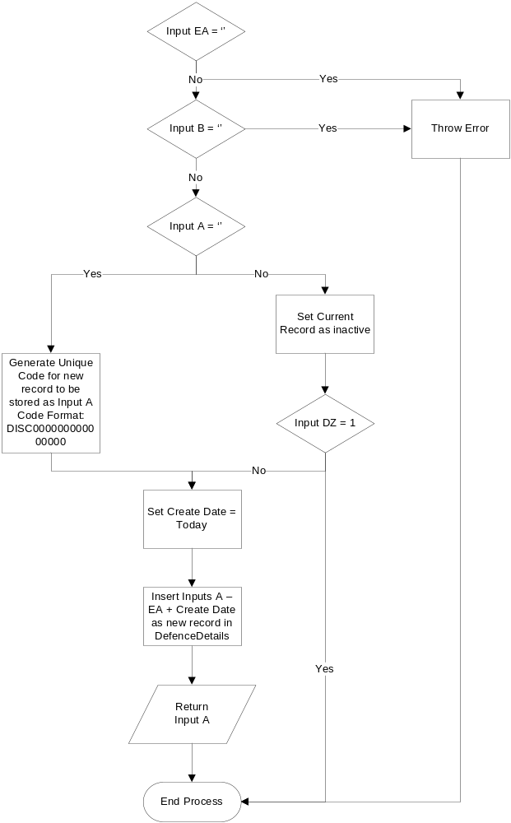
Figure 12 LTMM_Disclosure_Save

Outputs:
@pDisclosure_DisclosureCode

Document Templates

Please list below details of any document required as part of this scope.

Status:  New / Existing / Replacement  (please state) | Received Document Name (from business) | Document File Name  (ie Document.dot) | Document Description  (as viewed on FloCase) | Template Description Code  (Code for auto description) | Template Group:  BLM/ Documents/ Court Doc/ Letters/ Other  (Please State)
Existing | LOD (Standard Disclosure) | Court_N265_ListOfDocuments.dot | List of Documents – Standard Disclosure | LOD | Court Documents
New | Letter Requesting LOD to Selected Disclosure Contact | 30) List of standard documents required.rtf | Request for Documents from Party | Tbc | Letters

/tmp/lo/0000.doc

